Excalibur Solutions

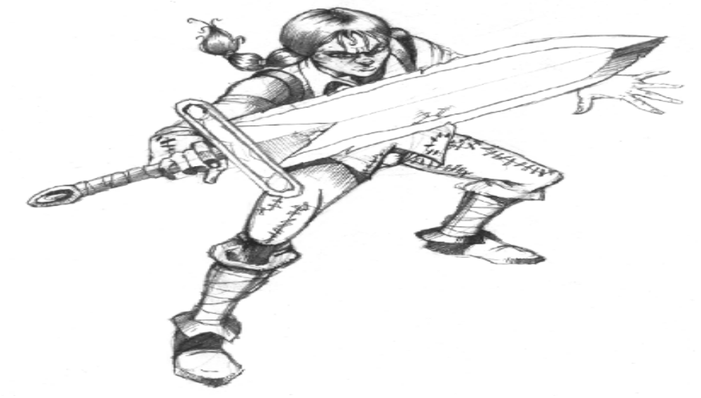
Excalibur Solution - Level 1 ‘Ort Underworld’
Password = ΧΧΧΧΧΧ (not needed)

Map

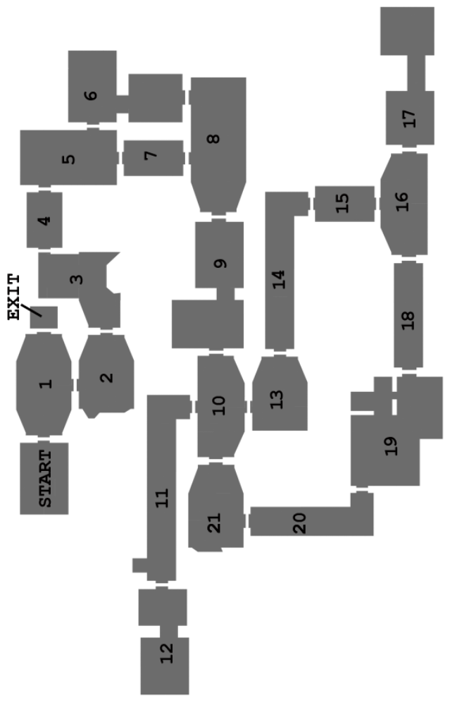
Walkthrough

- From the START go to ROOM 3 and speak to Trador.
- Go to ROOM 5 and get the GLASS from table.
- Go ROOM 6 and get the KEY from behind the rocks.
- Go to ROOM 8 and speak to the Ort Conman.
- Go to ROOM 9 and kill the Ort guard then use the KEY on the door.
- Go to ROOM 21 and kill the Ort Scumbag then pickup the HUMAN FLESH
- Go to ROOM 19 and speak to the Barman.
- Give him the GLASS. He will then give you the GROG.
- Go to ROOM 11 and drop the piece of HUMAN FLESH near to the rat hole.
- Pick up CECIL THE RAT when he comes out of hole.
- Go back to ROOM 8 and give the bottle of GROG to the Ort Conman, he will give you a KEY.
- Go to ROOM 16 and unlock the east door.
- Speak to the Tramp and give him CECIL THE RAT. He will give you the MEDIKIT.
- Go to ROOM 3 and give Trador the medikit. He will give you a POWER CELL.
- Go to ROOM 1 and give the POWER CELL to the robot.
- He will open the door; go through this to complete the level.

Excalibur Solution - Level 2 ‘Death Crypt’
Password = ΔΧΟΟΔ

Map

Walkthrough
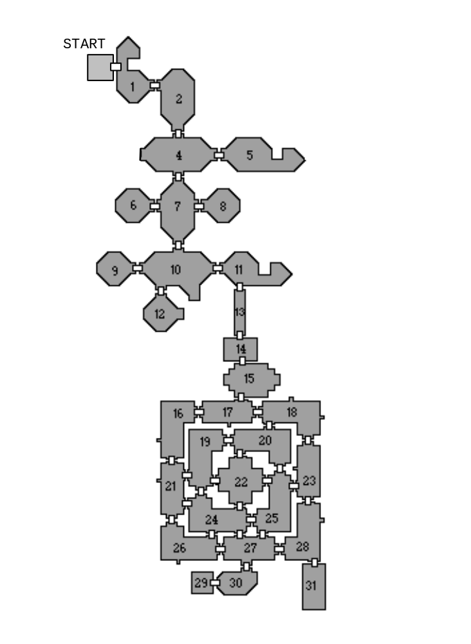

- From the START, go to ROOM 5 and get the LOG.
- Go to room 11 and get the second log.
- Go to room 10 and give the dry logs to the Hag, she will give you the HEALING POTION in return.
- Go to room 1and give the HEALING potion to stung man he will give you the LUCKY charm.
- Go to room 11. Use the LUCKY charm to unlock door.
- Carefully time your run down corridor 13 to miss the fireballs.
- Go to room 22, Kill reaper and pickup the LAB KEY.
- Go to ROOM 30, using the LAB KEY to open the door.
- Pickup the LARGE MALLET.
- Go to ROOM 14 and give the LARGE MALLET to the Undertaker. He will unlock the door to room 28)
- Go to room 28 and hit the eagle crest on the tombstone. Get the key.
- Use key to unlock the door to room 31. Turn the power off with the lever.
- Go to room 30. Wait for the monster to get up, then kill the monster.
- Talk to Scientist. Exit to room 29 to complete the level.

Excalibur Solution - Level 3 ‘The Trappings’
Password = ΟΧΟΟΔ

Map

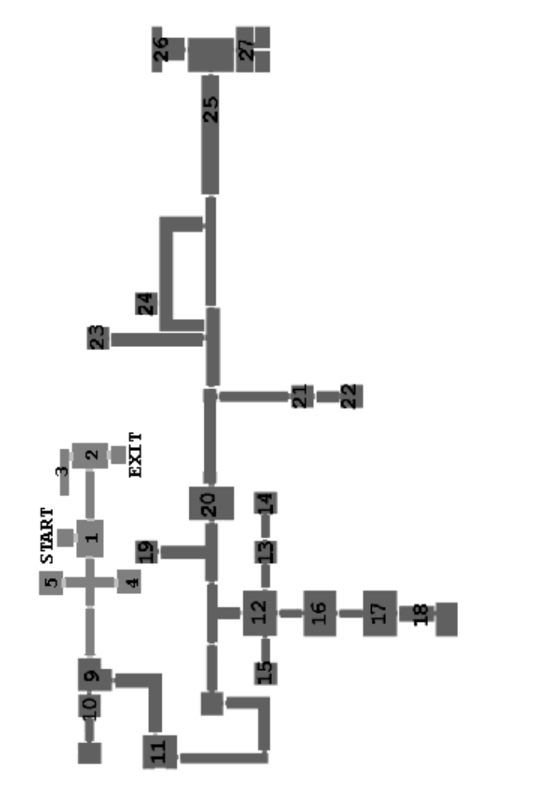

Walkthrough

- From the START, go to ROOM 1, kill the Ort guards, go to ROOM 2.
- Pickup the INSTANT IRON ORE then goto ROOM 3.
- Speak to the Locksmith, push the switch. Then go to ROOM 4 and pickup the GARLIC.
- Go to ROOM 9 and get the PHOENIX EGG.
- Go to ROOM 12, push the switch behind the boxes and quickly exit through the east door.
- Go straight to ROOM 14 and get the CRYSTAL.
- Go back to ROOM 13, quickly push the switch, use the teleporter and go through the west door.
- In ROOM 15 pick up the SPELL RECIPE, then exit using the teleporter .
- Go to ROOM 10, mix Spell of Fragmentation and use on trapped Accountant.
- Follow the Accountant and pick up the PENS AND PAPER from the desk.
- Go to ROOM 11, give Missionary the PENS AND PAPER and receive the HEALING POTION.
- Go to ROOM 4, give the POTION to the Old Woman and receive ORT KEY.
- Use the ORT KEY to open ROOM 5, kill the guard and pick up the LOCKET.
- Go to ROOM 12, follow the same sequence as before to get you to ROOM 15.
- Push switch and quickly go east. Push switch there and enter teleporter.
- Quickly go thru west door then push switch in there and go thru teleporter.
- Push switch and quickly use the teleporter, run to the south door which takes you to ROOM 16.
- Push switch behind the boxes, quickly run through ROOM 17, to ROOM 18.
- Give the LOCKET to the Old Man, he will turn off the force field, then get the BOTTLE OF BOOZE from the southern room.
- Use the teleporter to ROOM 12, go to ROOM 3 and give the BOTTLE OF BOOZE to the Drunken Locksmith.
- Combine, KEY MOULD with INSTANT IRON ORE to make IRON KEY.
- Use the IRON KEY on the door which is north then east of ROOM 12.
- Go to ROOM 23, enter and pickup the SPELL RECIPE.
- Go to ROOM 21, kill guards, take PRISION KEY, use it to enter ROOM 22, pickup the WATER POUCH.
- Go to the corridor east of the bridge, hit the secret door (right of the normal door) and go through it.
- Open secret door to ROOM 24, enter and use the WATER POUCH with the Barrel of Water.
- Go to ROOM 22, pickup the BETTLE and use the FULL WATER POUCH with the Prisoner. He will give you a RING.
- Smash the crate in front of ROOM 19, give the Woman the key and receive the ALPHA KEY.
- Go to the corridor outside ROOM 24, east through the cables, pickup the SULPHUR then south.
- Push the switch in the next corridor, then get back to the other side of the force field and push the other switch.
- Go to ROOM 25, mix Spell of Enchantment, use it on the Robber; he will move out of the way.
- Go to ROOM 26 and pickup the DYNAMITE.
- Drop the DYNAMITE in front of the treasure chest in the south-eastern corner of ROOM27.
- Go hide behind the crates, when the Captain goes to his treasure, run to his room and get the OMEGA KEY.
- Go back to ROOM 6 and use the teleporter , which will take you to ROOM 2.
- Use the ALPHA and OMEGA KEYS on the shuttered door and exit to complete the level.

Excalibur Solution - Level 4 ‘The Sewer’
Password = ΧΔΔΧΟ

Map

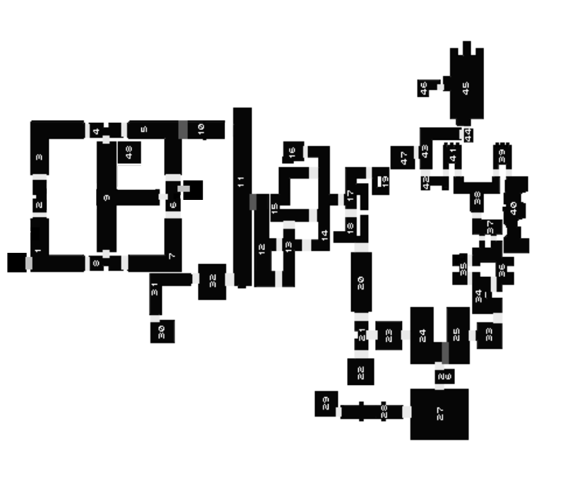
Walkthrough
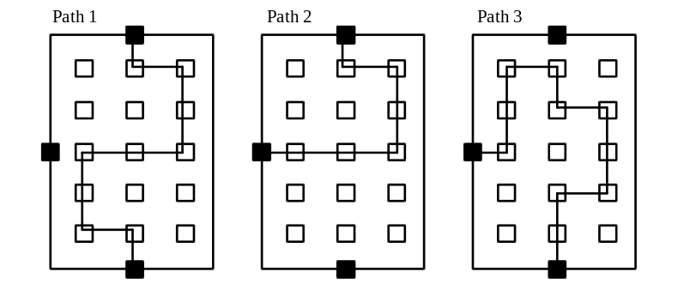

- From the START, work your way to ROOM 5, by going through ROOMS 8,9 and 4.
- Open the secret door to ROOM 10 and use the teleporter to ROOM 11.
- Quickly open the secret door (using your sword) to ROOM 12.
- Kill all of the Robbers in ROOMS 12 - 15 and 17 - 18. This will unlock the door to ROOM 20.
- Go to ROOM 24 and kill the Ratman. Talk to the Cripple and he will give you a KEY.
- Go to ROOM 16, use the KEY to open the door and pickup the PHOENIX EGG.
- Next kill the Spider in ROOM 27 and get the SPELL RECIPE.
- Go to ROOM 29 and use the teleporter which will take you to ROOM 30.
- Pickup the ACCESS CARD from ROOM 32 and go to ROOM 40. From here pickup the LAVA TOAD.
- Go to ROOM 43, mix the Spell of Fire and use it on the crate.

- The Paths referenced below are drawn on central screens in ROOM 9.

- Go to ROOM 45:

- Follow path 1: Then flip the switch.
- Follow path 2: Enter ROOM 46 and use the ACCESS CARD to activate teleporters.
- Follow path 3: To return to the entrance.

- Then go to ROOM 47 and use the teleporter to ROOM 48.
- Finally, go to ROOM 9 and stand on the teleporter in the centre to complete the level.

Excalibur Solution - Level 5 ‘Eco Sector’
Password = ΟΧΟΔΧ

Map

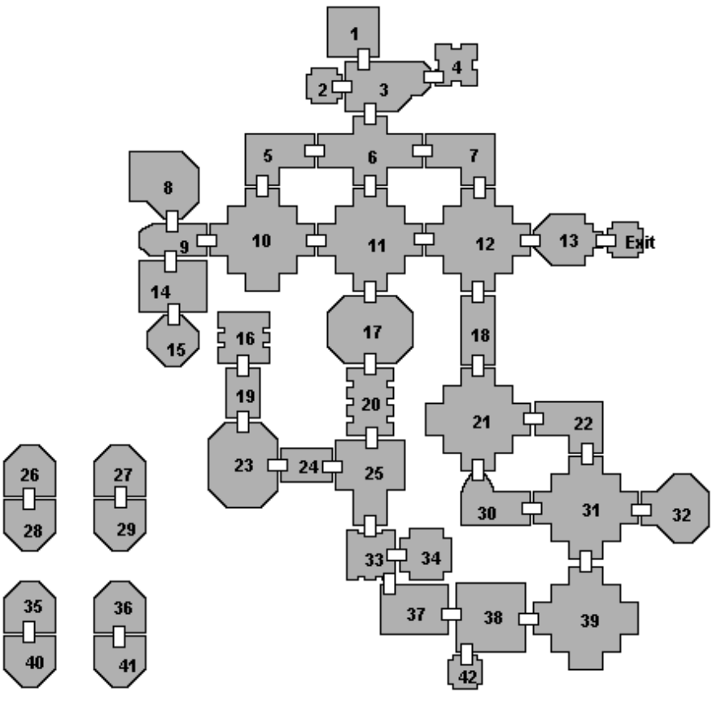

Walkthrough

- Starting in ROOM 16, pickup the EMPTY CAGE, then go to ROOM 25.
- Talk to the Injured Fabian, receive the ACCESS CARD and use it on the door to the north.
- Go to ROOM 17 and pickup the CHEESE.
- Go back to ROOM 24, combine the EMPTY CAGE with the CHEESE to make the MOUSE TRAP. Put this on the floor, wait for the mouse then pickup the TRAPPED MOUSE.
- Go to ROOM 12 and pickup the GREEN CODE from the central wall.
- Open the secret door to the south, enter ROOM 18 and pickup the BLUE CODE, the APPLE and the CHICKEN LEG.
- Open the secret door to the south, enter ROOM 21 and get the FEATHER.
- Go to ROOM 32, talk to the Children and receive the YELLOW CODE.
- Go to ROOM 6 and give the Secretary the TRAPPED MOUSE.
- Go to ROOM 3, talk to Mechanic then go to ROOM 4 and get RED CODE.
- Go to ROOM 1, pickup the SULPHUR then go back to ROOM 23.
- Enter the SE teleporter to ROOM 36, go to ROOM 41, enter the YELLOW CODE (312) then teleport back to ROOM 23.
- Enter the SW teleporter to ROOM 35, go to ROOM 40, enter the GREEN CODE (231) then teleport back to ROOM 23.
- Enter the NW teleporter to ROOM 28, go to ROOM 26, enter the RED CODE (321) then teleport back to ROOM 23.
- Enter the NE teleporter to ROOM 29, go to ROOM 27, enter the BLUE CODE (123) then teleport back to ROOM 23.
- Pickup the SPELL RECEPIE and go to ROOM 14.
- Mix the Spell of Keys and use it on the south door.
- Go to ROOM 15, pickup the WIRE and go to ROOM 3.
- Give the WIRE to the Mechanic, back away and let him use it on his console, then press the switch on the north wall to de-activate the security robots.
- Go to ROOM 13, press the switch and walk through the east door to complete the level.

Excalibur Solution - Level 6 ‘Fabian Water Hold’
Password = ΧΟΔΟΟ

Map

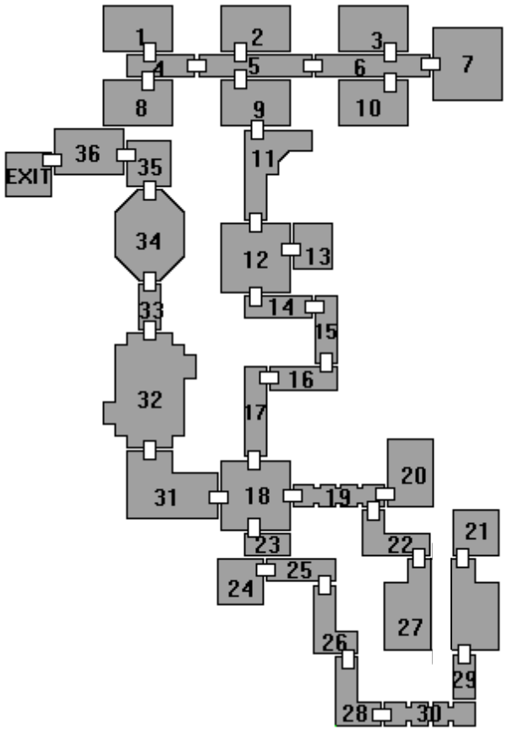
Walkthrough

- Staring in ROOM 27, pick up the FLARE.
- Go to ROOM 19 and pick up the SPELL RECEPIE.
- Go to room 20. Pick up the lava toad. Interact with the vending machine, find a coin in the coin-return slot.
- Go to room 18. Pick up the PHEONIX EGG.
- Go back to the vending machine in room 27. Use the coin on the vending machine to get the comic.
- Go to room 21. Get the access card and the SPELL RECEPIE.
- Go back to room 25. Mix the Fireball Spell, and use it to destroy crate. Pick up the WOODEN STICK left by the crate.
- Go to room 24. Kill the guard and pick up the BATTERY POWERD radio.
- Return to room 20. Give the comic to the Repair Man, who gives you an oil can.
- Go to room 17. Use the access card on the access device.
- Proceed to room 14 and get the beetle.
- Go to room 13, pick up the HANDLE and the TOADSTOOL
- Go to ROOM 11 and use the FLARE to scare the Gorrilla.
- Go to room 12. Mix the Spell of Healing and use it on the Caretaker. Wait for the Caretaker to reach his console. Give him the radio, allowing him to unlock the door to room 11.
- Go to room 2. Use the handle on the control panel.
- Go to room 9. Use the oil can on the control panel, then use the WOODEN stick on the control panel.
- Go to room 18. Talk to the Waterman, who gives you a key.
- Go to room 31. Kill both Technicians (The last one drops a security pass).
- Pickup the security pass. Use the key to unlock the barrier.
- Go to room 32. Use a Fireball Spell on the control panel.
- Go to room 35. Use the security pass on the small panel.
- Go to room 36. Kill all the guards. Talk to Fliptop.
- Walk through the west door to complete the level.

Excalibur Solution - Level 7 ‘Fabian Central’
Password = ΟΟΧΔ

Map

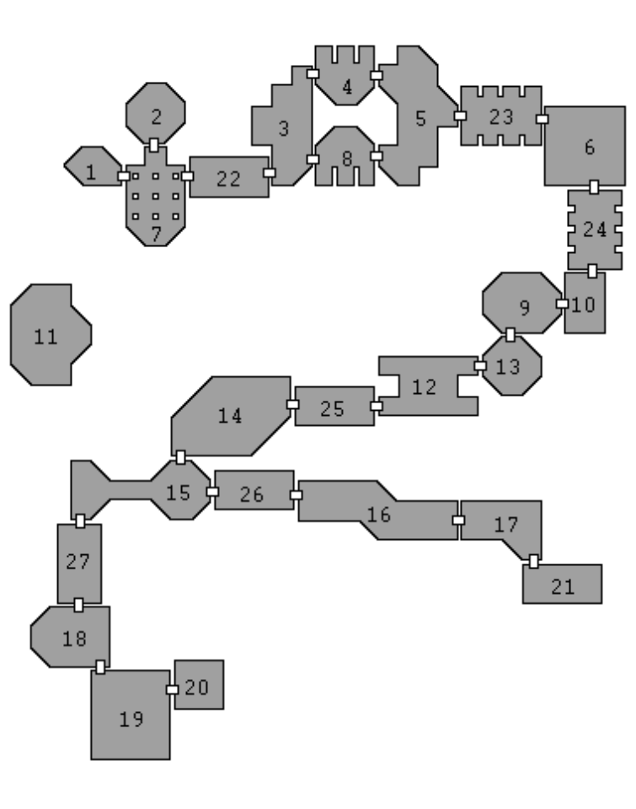
Walkthrough

- Go to room 7, get the torus key, which unlocks the door to ROOM 22.
- In ROOM 22, pick up both of the SPELL RECEPIES.
- Go to ROOM 3 and pickup the pencil and paper.
- Go to ROOM 8. Press the button on the wall, then quickly run to room 5 VIA ROOM 4. (The buttons unlock their opposite doors for a limited time).
- Get the feather from room 5.
- Go to ROOM 6 and get the dead rat.
- Go to ROOM 24 and get the rat poison.
- Go to ROOM 10. Press the button, which unlocks the secret door to ROOM 9.
- Get the SULPHUR from room 9. Go to room 12, then combine the feather and sulphur to produce the Spell of Keys.
- Use the spell of keys to gain entry to room 25.
- Combine the dead rat (or the water bottle) and the rat poison to produce poisoned food (or drink). Give the POISONED FOOD to the Ogre.
- Proceed to room 14. Get the dagger.
- Go to room 21. Give the dagger to the Thief who gives you a coin in return.
- Pickup the toadstool.
- Return to room 6. Use the coin on the vending machine to get a drink.
- Go to room 17. Give the drink to the thirsty man to get the code.
- Get the rations.
- Go to ROOM 5 and push the button to open both of the west doors.
- Go to room 7. Enter the code (1682) by walking over on the pads.
- Enter the teleporter to room 11. Get the VOICE SYNTHESIS UNIT.
- Return to room 13. Talk to Hal and give him the pad, then talk to him again.
- Give him the VOICE SYNTHESIS UNIT, for which he gives you a skull.
- Go to room 15. Use the Spell of Shadows. You should now be able to pass through the narrow corridor without being shot to pieces.
- Go to room 19. give the rations to the guard. Allow him to walk away, then step through the exit door to complete the level.

Excalibur Solution - Level 8 ‘The Prison’
Password = ΟΧΔΔ

Map

Walkthrough
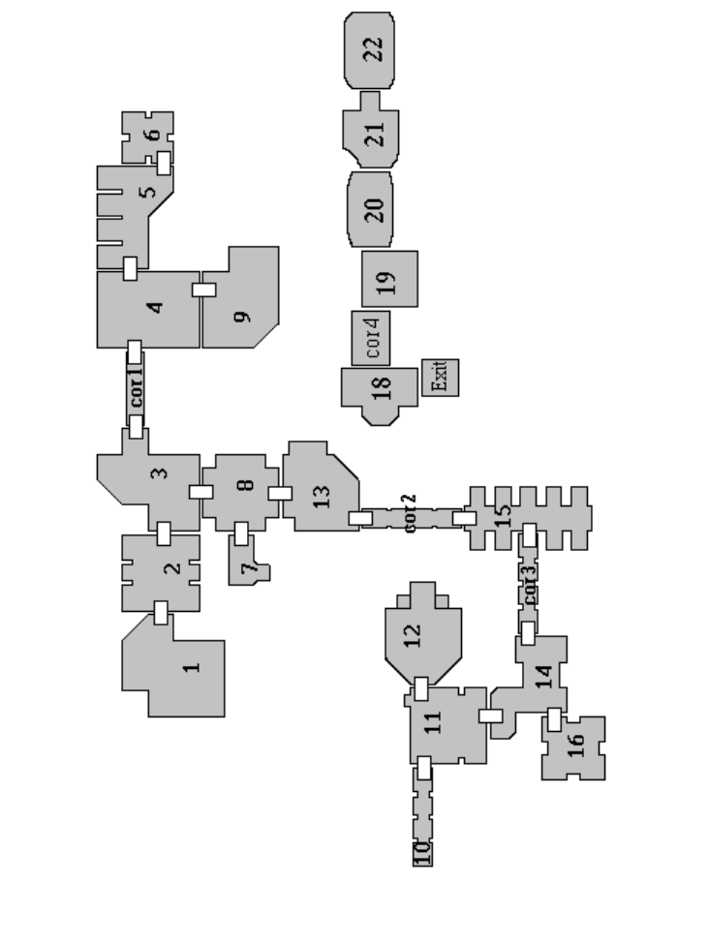

- Start in room 10. Go to room 11 and talk to the Mechanic.
- Go to room 13 and pickup the clock.
- Go to room 9, talk to Guard and swap the clock for the access card.
- Go to room 1 and pickup the Translator.
- Go to room 8, give translator to the Oldman and talk to him.
- Go to room 7, pickup the food and go to room 15.
- Use the access card on the control booth to disable the lasers.
- Talk to the Ort Prisoner with the feminine voice and get SPELL RECEPIE.
- Go to room 14, pickup the crystal and find the secret door in south west (as told by old man).
- Go into room 16, pickup the skull and the food.
- Go to room 5, but stay away from the vicious Guard with the bayonet.
- Mix and use the Spell of Armour.
- Then fight the Guard before the spell runs out.
- Go to room 6 and pickup the fuses.
- Go to room 11 and give the fuses to the Mechanic.
- Go to room 12 and use the teleporter which takes you to Room 18.
- Speak to Oscar and pickup the food if your health is low.
- Go to room 19, press the buttons in the order Red, Green and Blue.
- Go east through the caves to ROOM 22 where you will find Agent 99's body.
- Pickup the plans and go back to room 18.
- Give the plans to Oscar and he will unlock the door to the south.
- Exit south to complete the level.

Excalibur Solution - Level 9 ‘Elysian Labryinth’
Password = ΔΧΔΟΔ

Map

Walkthrough
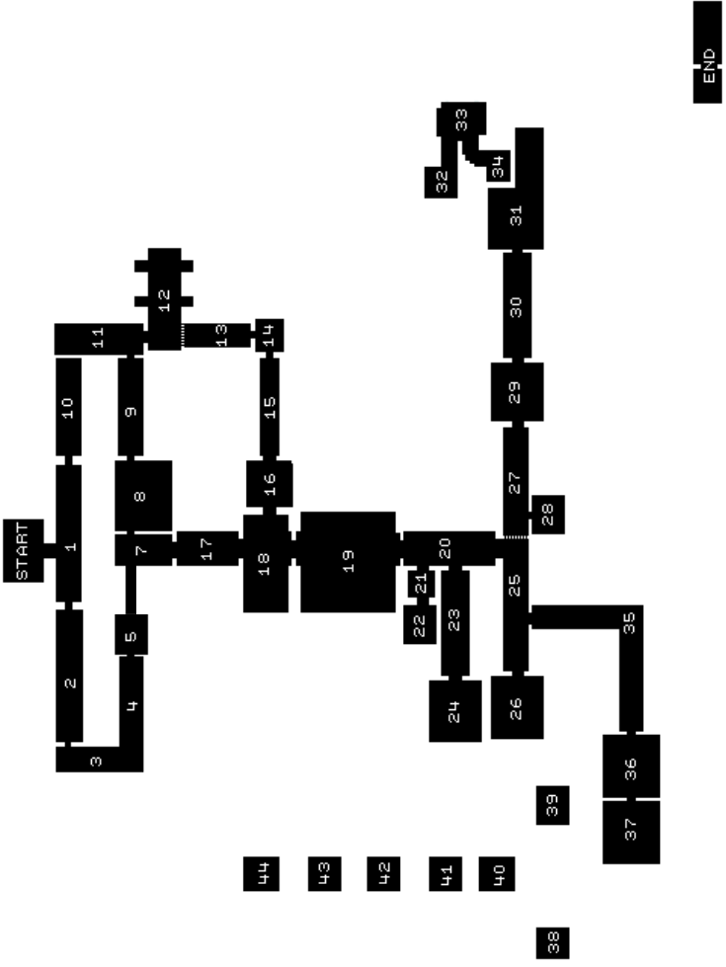

- Activate levers 1,3 and 4, numbered left to right, to remove ALL laser bars.
- Go to ROOM 12, Get the coin and the SULPHUR.
- Go to ROOM 8. Use coin on vending machine to get Electric Slush.
- Go to ROOM 14. Use the ELECTRIC Slush on the control panel to deactivate forcefield in ROOM 15.
- Go to ROOM 16. Activate the lever, which locks the door, then go to ROOM 19 (via room 17 then 18)
- Go to ROOM 22. Activate the lever, which turns off forcefield in ROOM 20.
- Go to ROOM 36. Get remote control.
- Go to ROOM 37. Activate the lever to turn on the teleporter.
- Teleport to ROOM 38. Activate lever 3.
- Teleport to ROOM 39. Activate lever 1.
- Teleport to ROOM 40. Activate lever 3.
- Teleport to ROOM 41. Activate lever 2.
- Teleport to ROOM 42. Activate lever 1, pick up the CD on floor.
- Teleport to ROOM 43. Activate lever 1.
- Teleport to ROOM 44. Activate lever 3.
- Teleport to ROOM 24. Activate lever to open door and pick up DOOR key.
- Go to ROOM 25. Activate secret door leading to ROOM 27.
- Go to ROOM 28. Get the FOOD.
- Use the DOOR KEY to open the door to ROOM 29.
- Go to ROOM 31. Teleport to ROOM 32. Talk to Seer in ROOM 33 to get the spell recepie.
- Get BETTLE from floor. Mix the Spell of Enchantment.
- Go to ROOM 32. Teleport to ROOM 24.
- Go to ROOM 6. Use Spell of Enchantment to scare Eunuch Guard.
- Then activate the lever and get the moonstone.
- Go to ROOM 33. Give the moonstone to Seer. Go to ROOM 34.
- Teleport to the END ROOM. Insert the CD into the CD Player. Use the remote to select track 5. (‘Wagner - Ride of the Valkerie’.)
- Use the wall mounted lever to open the exit door and complete the level.

Excalibur Solution - Level 10 ‘Subterrania’
Password = ΔΟΟΔΧ

Map

Walkthrough
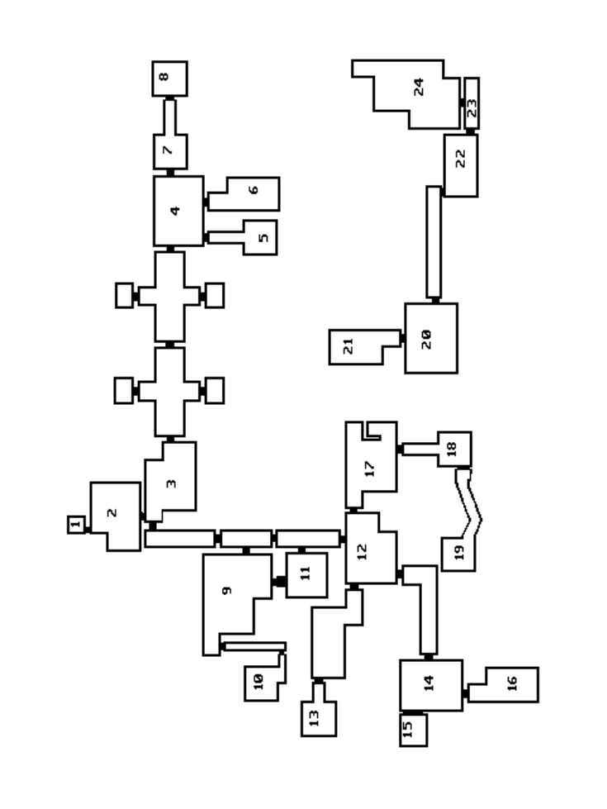

- Starting in ROOM 1, go to room 2 and pickup the Crystal.
- Go to room 3, pickup the spell recipe and talk to Ed.
- Go to room 9, talk to the Barman, read the SPELL RECEPIE and mix the Spell of Armour.
- Go to room 10, cast the Spell of Armour and kill the Gladiator.
- Once dead, pickup the gladiator key and the APPLE.
- Go to room 9 and use the gladiator key to get into room 11
- In room 11 pickup the toy key.
- Go to room 13 and talk to the hungry doctor.
- Go to room 14, pickup the bread and find the secret door to room 15.
- In room 15 use the teleporter to room 20.
- Go to room 22 and pickup the bottle of hedonica.
- Go to room 13 (via the teleporter in ROOM 20), combine hedonica and BREAD to make a sandwich.
- Give the sandwich to the Doctor and he will give you a battery.
- Go to room 21 (via ROOM 15), put the battery in the medipack machine.
- Use the lever to open the hatch and pickup the medipack.
- Go to room 24, give medipack to sick Dad and get the map from him.
- Go to room 16, kill enemy, give map to boy and get the toy mouse.
- Go to room 17, kill Guard and combine the toy key and toy mouse.
- Drop the mouse so it moves towards the force field.
- Use the lever to unlock the door to room 18, go in and talk to Oscar.
- Go to room 19 and teleport back to room 3.
- In room 3, talk to Ed and receive the CELL KEY. Wait for the alarms to sound and unlock the door using the cell key.
- Go to room 5, use lever. Go to room 6, talk to Chemist and get the access card.
- Go to room 4, use access card to get to room 7.
- Go to room 7, talk to the Traitor and kill him.
- Go to room 8 to complete the level.

Excalibur Solution - Level 11 ‘The Vault’
Password = ΧΧΔ

Map

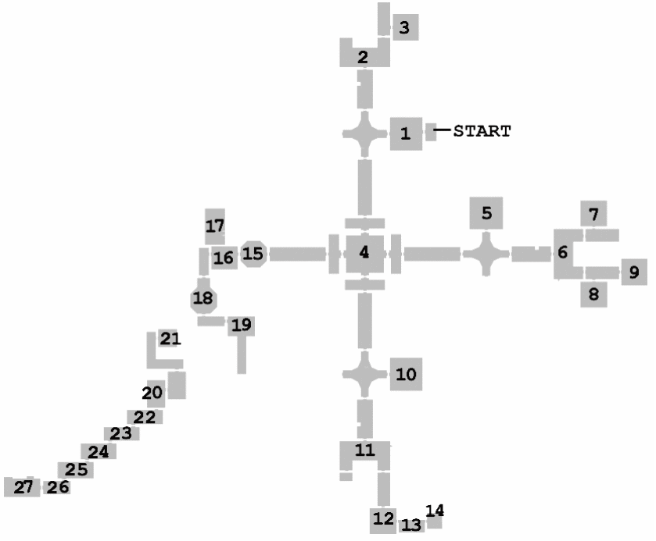
Walkthrough

- Exit the start room and speak to the Dying Man.
- Go to room 3 and speak to Joe.
- Go to room 6 and get the key from the Mail Box with the Star on it.
- Go to room 8 and get the medallion from beside the bed.
- Open room 5 with the key, speak to Tom. Get key from table in corner.
- Use key on door to south sector then go to room 11.
- Get the note from the Mail Box with the Semi-Circle on it.
- Go to room 13 and give the medallion to the Trashman.
- Let him move out of the way, go to room 14 and get the key from shelf.
- Go to room 4 and unlock door to west sector.
- Go to room 15 and speak to Mad Mick.
- Go to room 16 and open secret door in top left corner of room.
- Go into the room and kill the skeleton. He should change colour through yellow, purple, green and blue.
- Get the key from the coffin.
- Use the key to unlock the door leading to room 18. Go inside and push the buttons in colour sequence yellow, purple, green, blue.
- Go to room 19, kill Morgana, then use the teleporter to ROOM 20.
- Open the secret door to south of room and go thru it.
- Go to room 26 and kill the Statue. Pick up amulet from corner of room.
- Go to room 21 (speaking to mad mick on the way), and speak to wizard.
- Give him the amulet and he will give you a key in return.
- Go back to room 26 and unlock door.
- Go thru to room 27 and Excalibur will be there.
- Pickup EXCALIBUR to complete the level.

Excalibur Solution - Level 12 ‘Delavar’s Lair’
Password = ΟΔΧΟΟ

Map

Walkthrough
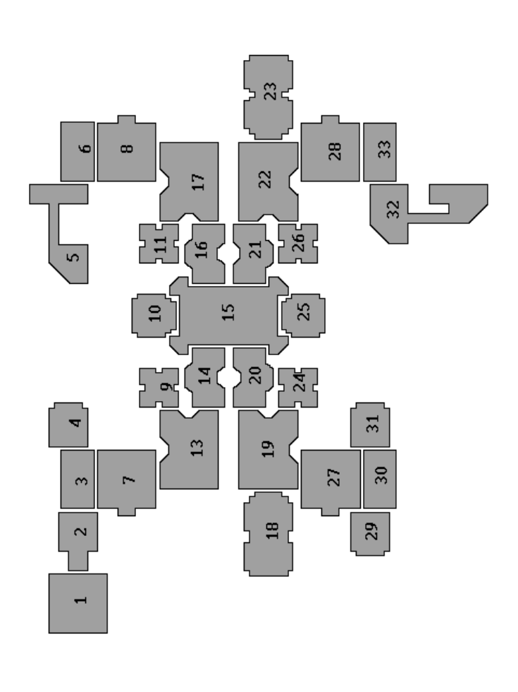

- Starting from room 25. Go to room 15 and pickup the phoenix egg.
- Go to room 24, pickup the AIR RUNE.
- Go to room 31, pickup the FIRE RUNE.
- Go to room 29, pickup the ASBESTOS MAT.
- Go to room 9, pickup the LAVA TOAD.
- Go to room 26, pickup the EARTH RUNE.
Go to room 23, pickup the KEY.
- Go to room 16. Unlock and enter ROOM 17, and pickup spell recipe.
- Go to room 11, pickup the KEY and go to room 6.
- Use the ASBESTOS MAT to block one of the fireball holes and pickup the BRASS COCK.
- Go to room 5, pickup the WATER RUNE.
- Go to room 8 and put the AIR RUNE & BRASS COCK on correct alters.
- Defeat the Air Goddess and pickup the AIR GLOBE out of holder.
- Go to room 19, unlock the door to room 18 and go inside.
- Interact with the fountains to turn them off, but one of them is jammed and needs the Fireball Spell to shift it.
- Pickup the SERPENT CHARM and go to room 27.
- Use the WATER RUNE and SERPENT CHARM on correct alters.
- Defeat the Water Serpent and pickup the WATER GLOBE.
- Go to room 13, pickup the KEY and unlock the door to room 7.
- Go to room 4, pickup the KEY.
- Go to room 2, press the two books to reveal hidden door.
- Go to room 1, hit the four fire statues to make them point away from the book, then pickup the book.
- Go to room 7, put the FIRE RUNE and BOOK onto correct alters.
- Defeat the Fire God and pickup the FIRE GLOBE.
- Go to room 22, unlock door to room 28 then go to room 32.
- Talk to the Prisoner, pickup the rat and give the rat to prisoner and take the CLAY BALL.
- Go to room 28, put the EARTH RUNE and CLAY BALL on to alters.
- Kill the Earth God and get the EARTH GLOBE.
- Go to room 15 and put globes onto correct coloured mountings in the corners of the room.
- This will open the exit door.
- Go to room 10 to complete the level.

Excalibur Solution - Level 13 ‘Project Eden’
Password = ΔΟΧΧΧ

Map

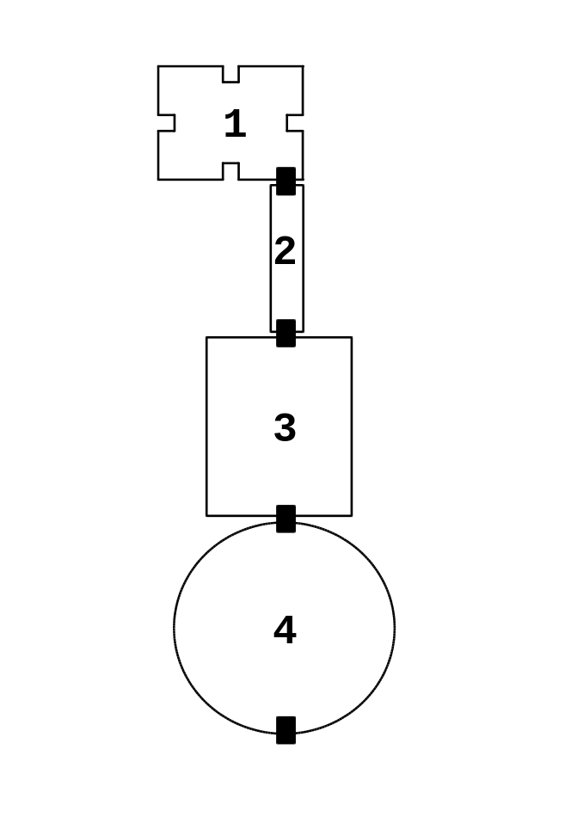
Walkthrough

- Starting in ROOM 1.
- Time your run down ROOM 2 to miss the fireballs.
- In ROOM 3, to kill Delavar you must reflect his energy bolts back by carefully timing your sword strokes.
- After defeating him go to ROOM 4 and exit through the southern door to reach the time machine and complete the game…

THE END

Excalibur Solution - Codes

Passwords

Level 1 = ΧΧΧΧΧΧ ‘Ort Underworld’
Level 2 = ΔΧΟΟΔ ‘Death Crypt’
Level 3 = ΟΧΟΟΔ ‘The Trappings’
Level 4 = ΧΔΔΧΟ ‘The Sewer’
Level 5 = ΟΧΟΔΧ ‘Eco Sector’
Level 6 = ΧΟΔΟΟ ‘Fabian Water Hold’
Level 7 = ΟΟΧΔ ‘Fabian Central’
Level 8 = ΟΧΔΔ ‘The Prision’
Level 9 = ΔΧΔΟΔ ‘Elysian Labyrinth’
Level 10 = ΔΟΟΔΧ ‘Subterrania’
Level 11 = ΧΧΔ ‘The Vault’
Level 12 = ΟΔΧΟΟ ‘Delavar’s Lair’
Level 13 = ΔΟΧΧΧ ‘Project Eden’

Special Moves

Jumping Slice = ΧΟΔ
Roundhouse Swing = ΧΟΔ

Cheats

Press START to pause the game then press:-

ΔΔΔ = Full Health
ΔΔΟΟ = Full Sword Power
ΟΔΟΔΔΔ = Skip Level
ΟΟΟΟΟΟ = Show Collision Boxes

Then select ‘Continue’ and press ‘Χ’ to active the cheat.

